FTI (First Time Installation)

- Create a file “starturl.txt” and add content http://192.168.1.200/fleex/vestel

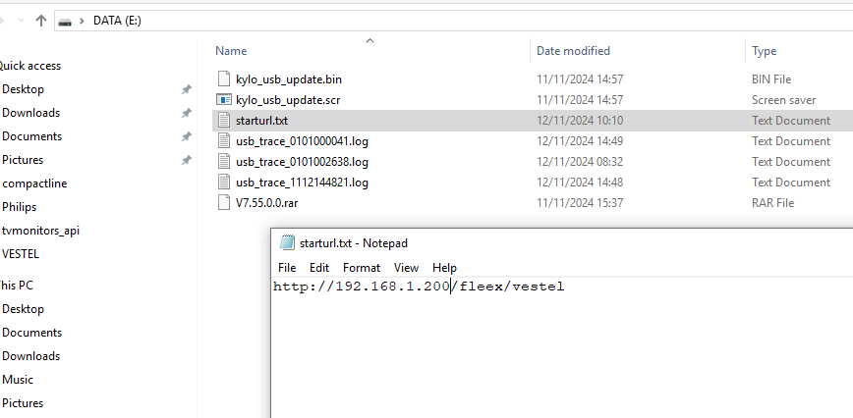
Where 192.168.1.200 is the IP address of the Headend, (Fleex Embedded must be enabled)

- Save the file to a USB flash disk (on root directory, not inside a folder)

- Insert the flash disk into the USB port and open the TV

- Open the hidden Service Menu (key Down + VolumeUP + ProgramUP + VolumeDown + ProgramDown)

- Press USB operations

- Restart TV. It should now open the Fleex Embedded app

Useful menus:
- Hotel TV (key Up + VolumeUP + ProgramUP + VolumeDown + ProgramDown)
- Network (key Left + VolumeUP + ProgramUP + VolumeDown + ProgramDown)
- Hidden (key Right + VolumeUP + ProgramUP + VolumeDown + ProgramDown)

To debug HTML app setup the chrome inspector to port 4725
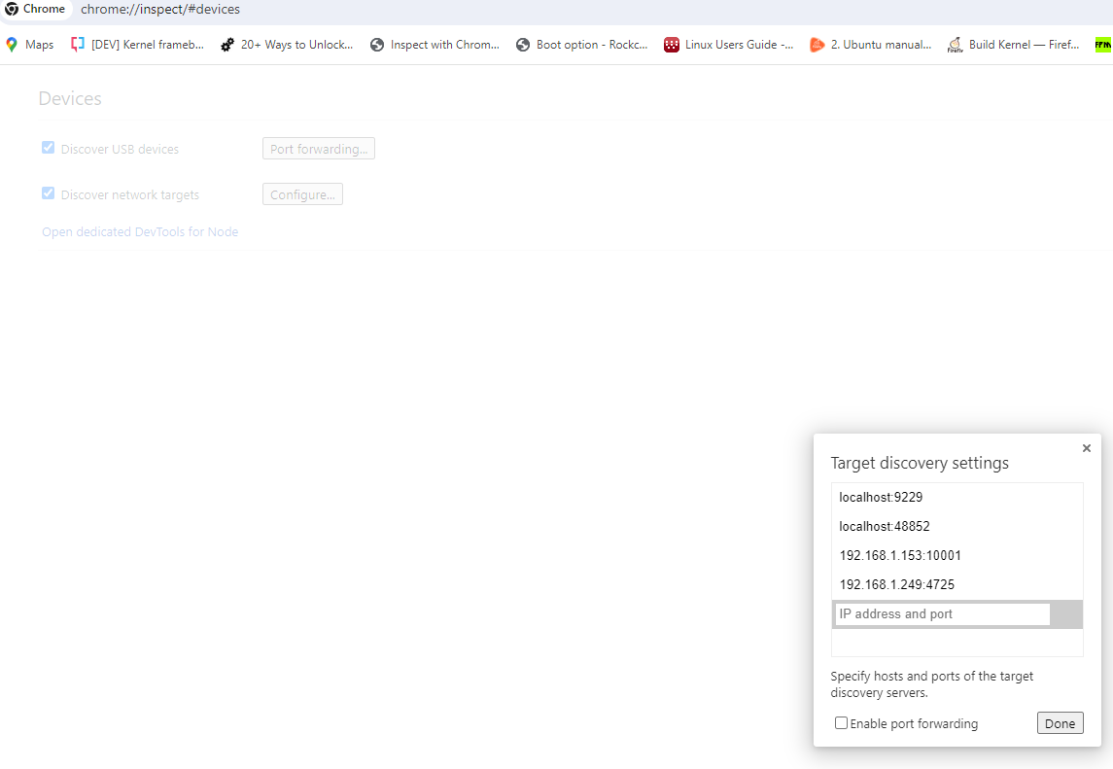
Set up TV_IP_ADDRESS:4725

